**CLI 가이드 명령 비교 (CLI vs API)**

**1. 버킷 목록 조회**

[root@test-bsh-server ~]# aws --endpoint-url=https://kr.object.ncloudstorage.com s3 ls

2020-12-18 16:10:51 sgb-cdn-bucket

2020-12-21 09:06:57 test-ob-storage

[root@test-bsh-server ~]# aws --endpoint-url=https://kr.object.ncloudstorage.com s3api list-buckets

{

"Buckets": [

{

"Name": "sgb-cdn-bucket",

"CreationDate": "2020-12-18T07:10:51.130Z"

},

{

"Name": "test-ob-storage",

"CreationDate": "2020-12-21T00:06:57.079Z"

}

],

"Owner": {

"DisplayName": "ncp-2532706-0",

"ID": "ncp-2532706-0"

}

}

**2. 오브젝트 목록 조회**

[root@test-bsh-server ~]# aws --endpoint-url=https://kr.object.ncloudstorage.com s3 ls s3://test-ob-storage

PRE test-folder/

[root@test-bsh-server ~]#

[root@test-bsh-server ~]# aws --endpoint-url=https://kr.object.ncloudstorage.com s3api list-objects --bucket test-ob-storage

{

"Contents": [

{

"Key": "test-folder/",

"LastModified": "2020-12-21T00:31:14.361Z",

"ETag": "\"d41d8cd98f00b204e9800998ecf8427e\"",

"Size": 0,

"StorageClass": "Standard",

"Owner": {

"DisplayName": "ncp-2532706-0",

"ID": "ncp-2532706-0"

}

},

{

"Key": "test-folder/Overlay vs Underlay.jpeg",

"LastModified": "2020-12-21T00:49:04.494Z",

"ETag": "\"567846862f81c6732254f49c3b8dad97\"",

"Size": 99258,

"StorageClass": "Standard",

"Owner": {

"DisplayName": "ncp-2532706-0",

"ID": "ncp-2532706-0"

}

},

{

"Key": "test-folder/setup.cfg",

"LastModified": "2020-12-21T14:05:55.184Z",

"ETag": "\"c9dc343ea87c78c27c50d8e6a139c5b0\"",

"Size": 142,

"StorageClass": "Standard",

"Owner": {

"DisplayName": "ncp-2532706-0",

"ID": "ncp-2532706-0"

}

}

]

}

**3. 오브젝트 업로드**

[root@test-bsh-server boto3]# aws --endpoint-url=https://kr.object.ncloudstorage.com s3 cp ./CODE_OF_CONDUCT.md s3://test-ob-storage/CODE_OF_CONDUCT.md

upload: ./CODE_OF_CONDUCT.md to s3://test-ob-storage/CODE_OF_CONDUCT.md

[root@test-bsh-server boto3]# aws --endpoint-url=https://kr.object.ncloudstorage.com s3api put-object --bucket test-ob-storage --key CODE_OF_CONDUCT-api.md --body ./CODE_OF_CONDUCT.md

{

"ETag": "\"942c1178dec0f08d0d7dfc3930794d48\""

}

[root@test-bsh-server boto3]#

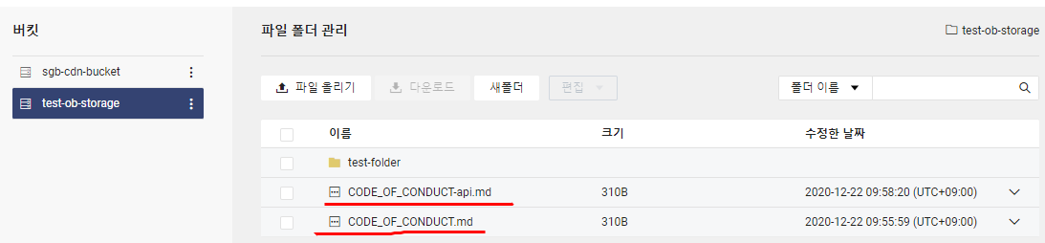

**4. 오브젝트 삭제**

[root@test-bsh-server boto3]# aws --endpoint-url=https://kr.object.ncloudstorage.com s3 rm s3://test-ob-storage/CODE_OF_CONDUCT.md

delete: s3://test-ob-storage/CODE_OF_CONDUCT.md

[root@test-bsh-server boto3]# aws --endpoint-url=https://kr.object.ncloudstorage.com s3api delete-object --bucket test-ob-storage --key CODE_OF_CONDUCT-api.md

[root@test-bsh-server boto3]#

버킷의 폴더내의 파일(오브젝트) 삭제

[root@test-bsh-server boto3]# aws --endpoint-url=https://kr.object.ncloudstorage.com s3 rm s3://test-ob-storage/test-folder/setup.cfg

delete: s3://test-ob-storage/test-folder/setup.cfg

버팃내의 폴더를 삭제하는 명령어는 ?? 🡺 폴더 api는 ? 🡺 Python SDK으로 실행하면 가능함

실행 방법은 python make-bucket.py 입력하면 파이썬이 실행되어 스토리지에 버킷 생성됨

버킷 생성하기

Vi make-object.py 로 아래 스크립트 입력

import boto3

service_name = 's3'

endpoint_url = 'https://kr.object.ncloudstorage.com'

region_name = 'kr-standard'

access_key = '5330500D81401E3CBACF'

secret_key = '47A8FEE8FBF383C06953536FBB647A5CD921B990'

if __name__ == "__main__":

s3 = boto3.client(service_name, endpoint_url=endpoint_url, aws_access_key_id=access_key,

aws_secret_access_key=secret_key)

bucket_name = 'test-object-bucket'

s3.create_bucket(Bucket=bucket_name)

폴더 생성하기

실행 방법은 python make-folder.py 입력하면 파이썬이 실행되어 test-object-bucket 버킷에 폴더 생성됨

Vi make-folder.py 로 아래 스크립트 입력

import boto3

service_name = 's3'

endpoint_url = 'https://kr.object.ncloudstorage.com'

region_name = 'kr-standard'

access_key = '5330500D81401E3CBACF'

secret_key = '47A8FEE8FBF383C06953536FBB647A5CD921B990'

if __name__ == "__main__":

s3 = boto3.client(service_name, endpoint_url=endpoint_url, aws_access_key_id=access_key,

aws_secret_access_key=secret_key)

bucket_name = 'test-object-bucket'

# create folder

object_name = 'test-folder/'

s3.put_object(Bucket=bucket_name, Key=object_name)

폴더 삭제하기

실행 방법은 python delete-folder.py 입력하면 파이썬이 실행되어 test-object-bucket 버킷에 폴더 삭제됨

Vi delete-folder.py 로 아래 스크립트 입력

import boto3

service_name = 's3'

endpoint_url = 'https://kr.object.ncloudstorage.com'

region_name = 'kr-standard'

access_key = '5330500D81401E3CBACF'

secret_key = '47A8FEE8FBF383C06953536FBB647A5CD921B990'

if __name__ == "__main__":

s3 = boto3.client(service_name, endpoint_url=endpoint_url, aws_access_key_id=access_key,

aws_secret_access_key=secret_key)

bucket_name = 'test-ojbect-bucket'

# delete folder

object_name = 'test-folder/'

s3.delete_object(Bucket=bucket_name, Key=object_name)

=======================================================